Project Design Phase

Technology Stack (Architecture & Stack)

|  |  |
| --- | --- |
| TEAM ID | PNT2022TMID12734 |
| PROJECT NAME | Real-Time River Water Quality Monitoring and Controlling System |

# TECHNICAL ARCHITECTURE

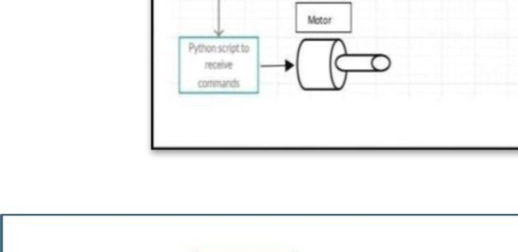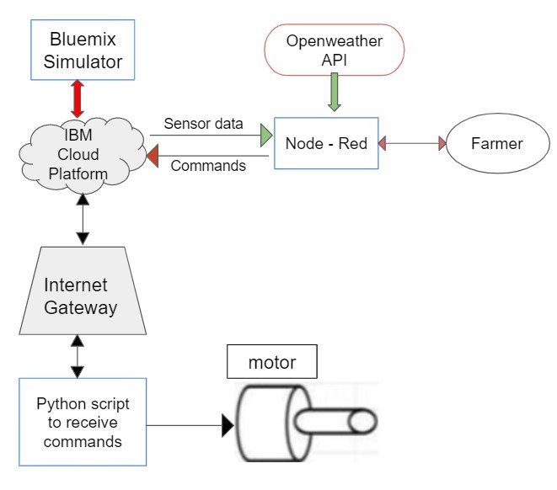

Table-1 : Components & Technologies:



|  |  |  |  |
| --- | --- | --- | --- |
| S.No | Component | Description | Technology |
| 1. | User Interface | How user interacts with application | HTML, CSS, Node-Red ,Cloud,etc |
| 2. | Application Logic-1 | Logic for a process in the application | JAVA/PYTHON |
| 3. | Application  Logic-2 | Logic for a process in the application | IBM WATSON STT services |
| 4. | Application Logic-3 | Logic for a process in the application | BM WATSON Assistant |
| 5. | Database | Data Type, Configurations etc | MySQL,PostgresSQL |
| 6. | Cloud  Database | Database Service on Cloud | IBM DB2,IBM Cloudant etc |
| 7. | File Storage | File storage requirements | IBM Block Storage or Other Storage  Service or Local Filesystem |
| 8. | External API-1 | Purpose of External API used in the application | IBM Weather API, etc |
| 9. | External API-2 | Purpose of External API used in the application | Aadhar API, etc |
| 10. | Machine | Purpose of External API used in the | Object Recognition Model, etc.. |
|  | Learning Model | application |  |
| 11. | Infrastructure | Application Deployment on Local | Local, Cloud Foundry, Kubernetes, etc. |
|  | (Server / | System / Cloud |  |
|  | Cloud) | Local Server Configuration:  Cloud Server Configuration |  |

Table-2: Application Characteristics:

|  |  |  |  |
| --- | --- | --- | --- |
| S.No | Characteristics | Description | Technology |
|  | Open-Source Frameworks | List the open-source | Technology of |
|  |  | frameworks used | Opensource framework |
| 2. | Security Implementations | List all the security / access | e.g. SHA-256, |
|  |  | controls implemented, use of | Encryptions, IAM |
|  |  | firewalls etc | Controls, OWASP etc. |
| 3. | Scalable Architecture | Justify the scalability of architecture (3 – tier, Micro- services) | Technology used |
| 4. | Availability | Justify the availability of application | Technology used |
| 5. | Performance | Design consideration for the performance of the application | Technology used |